**Luxoft Assignment**

There are 4 different requests for Sequence and IRIS & Pandas:

**PART 1: Sequence**

1. /sequence/elem/{n}: Returns the value of the sequence for “n”

**Assumptions:** take input integer and return the sequence

Input: 13

Output: 13 → 40 → 20 → 10 → 5 → 16 → 8 → 4 → 2 → 1

URL: <http://localhost:5000/sequence/elem/13>

Screenshot:

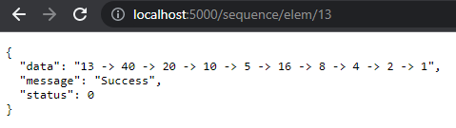

1. /sequence/longest/{n}: Returns the value smaller than n, that has the longest chain.

**Assumption:** input integer value and return a number having a longest chain and less than input integer.

Input: 11

Output: 9 (as longest chain is for number 9 which is less than input number 9.)

URL:

Screenshot:

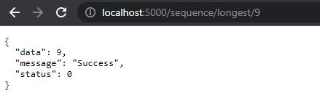

**PART 2: IRIS and Pandas**

<https://raw.githubusercontent.com/mwaskom/seaborn-data/master/iris.csv>.

1. /iris/group/sepal_length/{max}: Returns the number of each species with the maximum sepal_length of {max}

**Assumption:** Takes integer or float as a input value and returns each species with max   
 value of sepal_length (>=max)

Input: 7.9

Output: Returns all the species having max sepal_length upto 7.9.

URL: <http://localhost:5000/iris/group/sepal_length/8.0>

Screenshot:

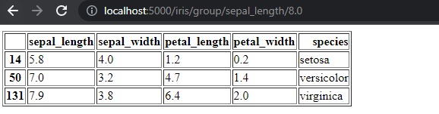

1. /iris/describe: Returns the basic statistics about the columns in data set, like min, max, count, mean etc.

**Assumption:** Read all data from csv

Output: Returns the table of csv data with count, mean, std, min, 25%, 50%, 75% and max values from the given csv file.

URL: <http://localhost:5000/iris/describe>

Screenshot:

